**SMART PRESCRIPTION APPLICATION**

Software Requirement Specification

By

**Mr. Natthakan Kaeokanpai 552115020**

**Mr. Phithiwat   Sitthitun     552115051**

Department of Software Engineering

College of Arts, Media and Technology

Chiang Mai University

Project Advisor

_____________________________

**Dr.Prompong Sugunnasil**

**Document Story**

|  |  |  |  |  |  |  |  |
| --- | --- | --- | --- | --- | --- | --- | --- |
| **Document Name** | **Version** | **Status** | | **Date** | **Viewable** | **Editable** | **Responsible** |
| **Documents** | | | | | | | |
| Software Requirement Specification_V.0.1 | - **Add**  Chapter One  Introduction  - **Add**  Chapter Two  Overall Description  - **Add**  Chapter Three  Functional Requirement  - **Add**  Chapter Four  Specific Requirement | | Reviewed | March 10th 2016 | NAT,PHI, PROM | NAT,PHI | NAT,PHI |
| Software Requirement Specification_V.1.0 | - **Update**  Chapter One  Introduction  - **Update**  Chapter Two  Overall Description  - **Update**  Chapter Three  Functional Requirement  - **Update**  Chapter Four  Specific Requirement  - **Add**  Chapter Five  Reference | | Released | March 10th 2016 | NAT,PHI, PROM | NAT,PHI | NAT,PHI |

*Acronym*

NAT = Natthakan Kaeokanpai

PHI = Phithiwat Sitthitun

PROM = Prompong Sugunnasil

**Table of content**

Chapter One | Introduction 3

1.1 Objective 3

1.2 Project Scope 4

1.3 Acronyms and Definitions 4

Chapter Two | Overall Description 5

2.1 Product Perspective 5

2.2 Product Features 6

2.3 User Classes and Characteristics 6

2.4 Operation Environment 6

Chapter Three | Functional Requiremen 7

3.1 User Requirement Specification 7

3.2 User Requirement Specification with the Software Requirement Specification 8

Chapter Four | Specific Requirement 16

4.1 Use Case Scenarios 16

4.2 Use Case Description 21

Chapter Five | References 62

# Chapter One | Introduction

## 1.1 Objective

The objective of the Software Design Document for “Smart prescription application” both Android mobile application and web application are to provide a description and explain of the design system including activity following requirements specification and before programming. This document is based on the project proposal, project plan and software requirement specification and help developers to understand how to work for this application.

## 1.2 Project Scope

“Smart prescription application” is an android application and web application that uses the electronic prescription in type of QR code that use for doctor, patient, and pharmacist. Smart prescription application require web application for generate QR code and android application to scan QR code pass built-in camera of a mobile phone to capture the QR code converts the QR code into text and numeric. Pharmacist can understand the prescription with name and detail of drug that doctor give to patient.

“Smart prescription application” can also can collect and report information of all prescriptions to the Food and Drug Administration, Ministry of Public Health organization or (FDA) for observing unusually dispensation in Thailand including report drug allergy that have been found in prescription of most of user that be allergic

The main features of “Smart prescription application” consist of:

Feature#1: Prescription system

Feature#2: Account management system

Feature#3: Authentication system

Feature#4: Prescription verification system

Feature#5: Report allergy system

Feature#6: Allergy drug summary report

## 

## 1.3 Acronyms and Definitions

1.3.1 Acronyms

UD Use Case Diagram  
 AD Activity Diagram  
 URS User Requirement Specification  
 SRS Software Requirement Specification  
 UC Use Case

1.3.2 Definitions

User Interface User interface (UI) is everything designed into an information device with which a human being may interact including display screen, keyboard, mouse, light pen, the appearance of a desktop, illuminated characters, help messages, and how an application program or a Web site invites interaction and responds to it.[1]

Feature Activity after input parameters and output the processing to user interface. It explains about functionality of an application used for requirements analysis, coding, design, and testing.

User Interface User interface (UI) is everything designed into an information device with which a human being may interact including display screen, keyboard, mouse, light pen, the appearance of a desktop, illuminated characters, help messages, and how an application program or a Web site invites interaction and responds to it.[2]

Use Case Diagram A use case diagram at its simplest is a representation of a user's interaction with the system that shows the relationship between the user and the different use cases in which the user is involved. A use case diagram can identify the different types of users of a system and the different use cases and will often be accompanied by other types of diagrams as well.[3]

Activity Diagram Activity diagrams are graphical representations of workflows of stepwise activities and actions with support for choice, iteration and concurrency. Activity diagrams show the overall flow of control. [4]

# Chapter Two | Overall Description

## 2.1 Product Perspective

“Smart prescription application” is an android application and web application that uses the electronic prescription in type of QR code that use for doctor, patient, pharmacist, and FDA. Smart prescription application require web application create the prescription of patient by doctor. Android application creates QR code from prescription of patient and scan QR code by pharmacist. Pharmacist can get the prescription with name and detail of drug that doctor give to patient on android application.

“Smart prescription application” can also can collect and report information of all allergy of patient to the Food and Drug Administration, Ministry of Public Health organization or (FDA) for observing unusually dispensation that have been found in Thailand.

## 2.2 Product Features

From the architecture of our project with schedule we separated the whole project of develops application according to this. The description is shown below:

Feature#1: Prescription system

Feature#2: Account management system

Feature#3: Authentication system

Feature#4: Verify prescription system

Feature#5: Report allergy system  
Feature#6: Allergy drug summary report

## 2.3 User Classes and Characteristics

The intended users for this application. They have to know basic of how to use android application to scan QR code.

## 2.4 Operation Environment

**- Internet**

**- Laptops**

1. Dell inspiron 5220

Processor: Intel Core i5 3210M (3.1 GHz)

Processor Memory: 8GB DDR3

Memory Hard Disk: 1000GB

Operating System: Window 7 Home Basic

1. Asus X550DP-DS101

AMD A-Series A10-5750M (2.50GHz) 8GB

Memory 1TB

HDD AMD Radeon

Windows 8 64-Bit

**- Mobile phone: Android Operating System with camera**

1. Asus zenfone 4.5

Android 4.4.2 (KitKat)

Processor: Intel Atom Z2520DualCore

CPU Speed: 1.2 GHz

Memory 8GB (Internal)

RAM 1GB

1. Samsung galaxy J7

OS: Android OS, v5.1 (Lollipop)

Processor: Quad-core 1.4 GHz Cortex-A53 & quad-core 1.0 GHz Cortex-A53  
Octa-core 1.5 GHz

Memories 16 GB, 1.5 GB RAM 8GB (Internal)

Chapter Three | Functional Requiremen**t**

## 3.1 User Requirement Specification

**Smart Prescription Application URS**

**Feature #1 Prescription System**

URS-1: Doctors can create patient’s profiles on the web application.

URS-2: Doctors can update patient’s profiles on the web application.

URS-3: Doctors can delete patient’s profiles on the web application.

URS-4: Doctors can search patient’s profiles on the web application.

URS-5: Doctors can view patient’s profiles on the web application.

URS-6: Doctors can view a list of patient’s profiles on the web application.

**Feature #2 Account Management Systems**

URS-7: Administrations can create user’s profiles on the web application.

URS-8: Administrations can update user’s profiles on the web application.

URS-9: Administrations can delete user’s profiles on the web application.

URS-10: Administrations can search user’s profiles on the web application.

URS-11: Administrations can view user’s profiles on the web application.

URS-12: Administrations can view a list of users on the web application.

**Feature #3 Authentication Systems**

URS-13: Doctors, Administrations, and FDAs can login to the web application.

URS-14: Doctors, Administrations, and FDAs can logout from the web application.

URS-15: Patients can login to the mobile application.

URS-16: Patients can logout from the mobile application.

**Feature#4 Verify prescription Systems**

URS-17: Patients can view the QR code on the mobile application.

URS-18: Pharmacists can scan the QR code on the mobile application.

URS-19:Pharmacists can notify the time of dispensation to patient’s profile on the mobile application.

**Feature#5 Report allergy Systems**

URS-20: Doctors can create allergy reports on the web application.

URS-21: Doctors can update allergy reports on the web application.

URS-22: Doctors can delete allergy reports on the web application.

URS-23: Doctors can search allergy reports on the web application.

URS-24: Doctors can view allergy drug reports on the web application.

URS-25: Doctors can view a list of allergy drug reports on the web application.

**Feature#6 Allergy Drug Summary Report**

URS-26: FDAs can view allergy reports on the web application.

URS-27: FDAs can view a list of allergy reports on the web application.

## 3.2 User Requirement Specification with the Software Requirement Specification

**URS-1: Doctors can create patient’s profiles on the web application.**

SRS-1: The system shall provide menu bars (home, patient profile, allergy report, and logout) and operation menu bars (create patient and list patient).

SRS-2: The system shall provide patient’s profiles form for input information which includes (personal ID, name, surname, prescription, responsible, and username).

SRS-3: The system shall displays error message “Personal ID cannot be blank.” when doctors do not input personal ID.

SRS-4: The system shall displays error message “Personal ID is already exist. Please change.” when doctors input personal ID that exist in the database.

SRS-5: The system shall displays error message “Personal ID is too short (minimum is 13 characters).” when doctors input personal ID less than 13 digits.

SRS-6: The system shall displays error message “Personal ID must be an integer.” when doctors input personal ID which are not a number.

SRS-7: The system shall displays error message “Name cannot be blank.” when doctors do not input name.

SRS-8: The system shall displays error message “Surname cannot be blank.” when doctors do not input surname.

SRS-9: The system shall displays error message “Prescription cannot be blank.” when doctors do not input prescription.

SRS-10: The system shall displays error message “Responsible cannot be blank.” when doctors do not input responsible.

SRS-11: The system shall displays error message “Username cannot be blank.” when doctors do not input username.

SRS-12: The system shall displays error message “Username is already exist. Please change.” when doctors input username that exist in the database.

SRS-13: The system shall displays error message “Name is invalid.” when doctors input name with not a letter on English language.

SRS-14: The system shall displays error message “Surname is invalid.” when doctors input surname with not a letter on English language.

SRS-15: The system shall displays error message “Responsible is invalid.” when doctors input responsible with not a letter on English language.

SRS-16: The system shall provide a ‘Create’ button for creating patient’s profiles.

SRS-17: The system shall generate the code for users, which is 5 digits number.

SRS-18: The system shall stores date time of creating profile into the database when doctors click ‘Create’ button.

SRS-19: The system shall saves data of patient’s profiles to database when doctors click a ‘Create’ button and redirect user to patient’s profile UI.

**URS-2: Doctors can update patient’s profiles on the web application.**

SRS-20: System shall provide the manage profile UI, which includes menu bars (home, patient profile, allergy report, and logout) and operation menu bars (create patient and list patient).

SRS-21: The system shall provide the table lists of patient and search text fields, which includes personal ID, name, surname, and responsible.

SRS-22: The system shall provide ([Update](http://localhost/smart_pres/index.php/profile/update/3333333333333)) ‘Update’ button in the last column of table between view button and delete button.

SRS-23: The system shall validates (personal ID, name, surname, or responsible).

SRS-24: The system shall retrieves patient’s profiles from database.

SRS-25: The system shall provide patient’s profiles form that has default information (personal ID, name, surname, prescription, responsible, username, and code).

SRS-3: The system shall displays error message “Personal ID cannot be blank.” when doctors do not input personal ID.

SRS-4: The system shall displays error message “Personal ID is already exist. Please change.” when doctors input personal ID that exist in the database.

SRS-5: The system shall displays error message “Personal ID is too short (minimum is 13 characters).” when doctors input personal ID less than 13 digits.

SRS-6: The system shall displays error message “Personal ID must be an integer.” when doctors input personal ID which are not a number.

SRS-7: The system shall displays error message “Name cannot be blank.” when doctors do not input name.

SRS-8: The system shall displays error message “Surname cannot be blank.” when doctors do not input surname.

SRS-9: The system shall displays error message “Prescription cannot be blank.” when doctors do not input prescription.

SRS-10: The system shall displays error message “Responsible cannot be blank.” when doctors do not input responsible.

SRS-11: The system shall displays error message “Username cannot be blank.” when doctors do not input username.

SRS-12: The system shall displays error message “Username is already exist. Please change.” when doctors input username that exist in the database.

SRS-13: The system shall displays error message “Name is invalid.” when doctors input name with not a letter on English language.

SRS-14: The system shall displays error message “Surname is invalid.” when doctors input surname with not a letter on English language.

SRS-15: The system shall displays error message “Responsible is invalid.” when doctors input responsible with not a letter on English language.

SRS-26: The system shall provide ‘Save’ button for saving a new patient’s profiles.

SRS-27: The system shall stores date time of updating profile into the database when doctors click ‘Save’ button.

SRS-28: The system shall saves a new data of patient’s profiles to database when doctors click ‘Save’ button and redirect user to patient’s profile UI.

SRS-29: The system shall provide the ‘Next >’ button for change to the next table lists page.

SRS-30: The system shall provide the ‘< Previous’ button for changes to the previous table lists page.

SRS-31: The system shall displays the message to show the number amount of patient’s profiles on the present table of patient’s profile lists.

SRS-32: The system shall displays the message to show the total amount of patient’s profiles.

**URS 3: Doctors can delete patient’s profiles on the web application.**

SRS-20: System shall provide manage profiles UI, which includes menu bars (home, patient- profile, allergy report, and logout) and operation menu bars (list profile and create profile).

SRS-21: The system shall provide the table lists of patient and search text fields, which includes personal ID, name, surname, and responsible.

SRS-33: The system shall provide ([Delete](http://localhost/smart_pres/index.php/profile/delete/1266225448844)) ‘Delete’ button in the last column of table.

SRS-23: The system shall validates (personal ID, name, surname, or responsible).

SRS-24: The system shall retrieves patient’s profiles from database.

SRS-34: The system shall interface to show the confirm box “Are you sure you want to delete this item?” when doctors click ‘Delete’ button on the web application.

SRS-35: The system shall be able to delete a patient’s profiles from the database when doctors click ‘OK’ button on the confirm box.

SRS-36: The system shall be not able to delete a patient’s profiles from the database when doctors click ‘Cancel’ button.

SRS-29: The system shall provide the ‘Next >’ button for change to the next table lists page.

SRS- 30: The system shall provide the ‘< Previous’ button for changes to the previous table lists page.

SRS-31: The system shall displays the message to show the number amount of patient’s profiles on the present table of patient’s profile lists.

SRS-32: The system shall displays the message to show the total amount of patient’s profiles.

**URS 4: Doctors can search patient’s profiles on the web application.**

SRS-20: System shall provide manage profiles UI, which includes menu bars (home, patient- profile, allergy report, and logout) and operation menu bars (list profile and create profile).

SRS-21: The system shall provide the table lists of patient and search text fields, which includes personal ID, name, surname, and responsible.

SRS-23: The system shall validates (personal ID, name, surname, or responsible).

SRS-24: The system shall retrieve patient’s profiles from database.

SRS-37: The system shall displays the message “*No results found*”, when personal ID does not exist in the database.

SRS-38: The system shall displays the message “*No results found*”, when name does not exist in the database.

SRS-39: The system shall displays the message “*No results found*”, when surname does not exist in the database.

SRS-40: The system shall displays the message “*No results found*”, when responsible does not exist in the database.

SRS-41: The system shall displays the patient’s information on the table, when searching found the match letters are exist in the database.

SRS-29: The system shall provide the ‘Next >’ button for change to the next table lists page.

SRS-30: The system shall provide the ‘< Previous’ button for changes to the previous table lists page.

SRS-31: The system shall displays the message to show the number amount of patient’s profiles on the present table of patient’s profile lists.

SRS-32: The system shall displays the message to show the total amount of patient’s profiles.

**URS-5: Doctors can view patient’s profiles on the web application.**

SRS-20: The system shall provide manage profiles UI, which includes menu bars (home, patient- profile, allergy report, and logout) and operation menu bars (list profile and create profile).

SRS-21: The system shall provide the table lists of patient and search text fields, which includes personal ID, name, surname, and responsible.

SRS-42: The system shall provide ( [View](http://localhost/smart_pres/index.php/profile/3333333333333) ) ‘View’ button in the last column of table.

SRS-23: The system shall validates (personal ID, name, surname, or responsible).

SRS-24: The system shall retrieves patient’s profiles from database.

SRS-43: The system shall provide the patient’s profiles UI, which includes personal ID, name, surname, prescription, responsible, username, code, and date of patient’s profiles.

**URS-6: Doctors can view a list of patient’s profiles on the web application.**

SRS-44: The system shall provide a list of patient UI, which includes menu bar (home, patient profile, allergy report, and logout) and operation menu bar (create patient and manage patient).

SRS-45: The system shall provide a list of patient’s profiles, which includes personal ID, name, surname, and responsible.

SRS-46: The system shall provide the ‘Next >’ button for change to the next lists page.

SRS-47: The system shall provide the ‘< Previous’ button for changes to the previous lists page.

SRS-48: The system shall displays the message to show the number amount of patient’s profiles on the present list page.

SRS-32: The system shall displays the message to show the total amount of patient’s profiles.

**URS-7: Administrators can add user’s profiles on the web application.**

SRS-49: The system shall provide the menu bars (home, account, and logout) and operation menu bars (list user and manage user).

SRS-50: The system shall provide user’s profilesform to fill information of user which includes (firstname, surname, username, password and confirm-password).

SRS- : The system shall displays error message “Position cannot be blank.” when administrator do not select the position.

SRS-7: The system shall displays error message “Name cannot be blank.” when administrator do not input name.

SRS-8: The system shall displays error message “Surname cannot be blank.” when administrator do not input surname.

SRS-9: The system shall displays error message “Prescription cannot be blank.” when administrator do not input prescription.

SRS-10: The system shall displays error message “Responsible cannot be blank.” when administrator do not input responsible.

SRS-11: The system shall displays error message “Username cannot be blank.” when administrator do not input username.

SRS-12: The system shall displays error message “Username is already exist. Please change.” when administrator input username that exist in the database.

SRS-13: The system shall displays error message “Name is invalid.” when administrator input name with not a letter on English language.

SRS-14: The system shall displays error message “Surname is invalid.” when administrator input surname with not a letter on English language.

SRS- : The system shall displays error message “Password cannot be blank.” when administrator do not input password.

SRS- : The system shall displays error message “Confirm-Password cannot be blank.” when administrator do not input confirm password.

SRS- : The system shall displays error message “Password and Confirm-Password do not Match, Please try again.” when administrator input password or confirm password not match.

SRS- : The system shall displays error message “Group cannot be blank” when administrator do not select the group.

SRS-53: System shall provide ‘Create’ button for creating user’s profiles.

SRS-54: System shall save data of user’s profiles to database when administrator click ‘Create’ button and redirect administrator to user’s profiles UI.

**URS-8: Administrators can update user’s profiles on the web application.**

SRS-55: The system shall provide the manage user UI, which includes menu bars (home, account, and logout) and operation menu bars (create user and list user).

SRS-: The system shall provide the table lists of user and search text fields, which includes position, name, and surname.

SRS-22: The system shall provide ([Update](http://localhost/smart_pres/index.php/profile/update/3333333333333)) ‘Update’ button in the last column of table between view button and delete button.

SRS-57: System shall validate (position, name, and surname).

SRS-58: System shall retrieve user’s profiles from database.

SRS-59: System shall provide user’s profilesform that has default information (position, firstname, surname, username, password, confirm password and group).

(firstname, surname, username, password and confirm-password).

SRS- : The system shall displays error message “Position cannot be blank.” when administrator do not select the position.

SRS-7: The system shall displays error message “Name cannot be blank.” when administrator do not input name.

SRS-8: The system shall displays error message “Surname cannot be blank.” when administrator do not input surname.

SRS-9: The system shall displays error message “Prescription cannot be blank.” when administrator do not input prescription.

SRS-10: The system shall displays error message “Responsible cannot be blank.” when administrator do not input responsible.

SRS-11: The system shall displays error message “Username cannot be blank.” when administrator do not input username.

SRS-12: The system shall displays error message “Username is already exist. Please change.” when administrator input username that exist in the database.

SRS-13: The system shall displays error message “Name is invalid.” when administrator input name with not a letter on English language.

SRS-14: The system shall displays error message “Surname is invalid.” when administrator input surname with not a letter on English language.

SRS- : The system shall displays error message “Password cannot be blank.” when administrator do not input password.

SRS- : The system shall displays error message “Confirm-Password cannot be blank.” when administrator do not input confirm password.

SRS- : The system shall displays error message “Password and Confirm-Password do not Match, Please try again.” when administrator input password or confirm password not match.

SRS- : The system shall displays error message “Group cannot be blank” when administrator do not select the group.

SRS-64: The system shall provide ‘Save’ button for saving a new user’s profiles.

SRS-65: The system shall saves a new data of user’s profiles to database when administrator clicks ‘Save’ button and redirect administrator to user’s profile UI.

SRS-29: The system shall provide the ‘Next >’ button for change to the next table lists page.

SRS-30: The system shall provide the ‘< Previous’ button for changes to the previous table lists page.

SRS-31: The system shall displays the message to show the number amount of user’s profiles on the present table of patient’s profile lists.

SRS-32: The system shall displays the message to show the total amount of user’s profiles.

**URS-9: Administrators can delete user’s profiles on the web application**.

SRS-55: The system shall provide the manage user UI, which includes menu bars (home, account, and logout) and operation menu bars (create user and list user).

SRS-: The system shall provide the table lists of user and search text fields, which includes position, first name, and surname.

SRS-33: The system shall provide ([Delete](http://localhost/smart_pres/index.php/profile/delete/1266225448844)) ‘Delete’ button in the last column of table.

SRS-: The system shall validate (position, name, and surname).

SRS-: The system shall retrieve user’s profiles from database.

SRS-34: The system shall interface to show the confirm box “Are you sure you want to delete this item?” when administrators click ‘Delete’ button on the web application.

SRS-: The system shall be able to delete a user’s profiles from the database when administrators click ‘OK’ button on the confirm box.

SRS-: The system shall be not able to delete a user’s profiles from the database when doctors click ‘Cancel’ button.

SRS-29: The system shall provide the ‘Next >’ button for change to the next table lists page.

SRS-30: The system shall provide the ‘< Previous’ button for changes to the previous table lists page.

SRS-31: The system shall displays the message to show the number amount of user’s profiles on the present table of patient’s profile lists.

SRS-32: The system shall displays the message to show the total amount of user’s profiles.

**URS-10: Administrations can search user’s profiles on the web application.**

SRS-55: The system shall provide the manage user UI, which includes menu bars (home, account, and logout) and operation menu bars (create user and list user).

SRS-: The system shall provide the table lists of user and search text fields, which includes position, name, and surname.

SRS-: The system shall validates (position, name, and surname).

SRS-: The system shall retrieve user’s profiles from database.

SRS-: The system shall displays the message “*No results found*”, when position does not exist in the database.

SRS-: The system shall displays the message “*No results found*”, when name does not exist in the database.

SRS-39: The system shall displays the message “*No results found*”, when surname does not exist in the database.

SRS-41: The system shall displays the user’s information on the table, when searching found the match letters are exist in the database.

SRS-29: The system shall provide the ‘Next >’ button for change to the next table lists page.

SRS-30: The system shall provide the ‘< Previous’ button for changes to the previous table lists page.

SRS-31: The system shall displays the message to show the number amount of user’s profiles on the present table of patient’s profile lists.

SRS-32: The system shall displays the message to show the total amount of user’s profiles.

**URS -11: Administrations can view user’s profiles on the web application.**

SRS-55: The system shall provide the manage user UI, which includes menu bars (home, account, and logout) and operation menu bars (create user and list user).

SRS-: The system shall provide the table lists of user and search text fields, which includes position, name, and surname.

SRS-: The system shall validates (position, name, and surname).

SRS-: The system shall retrieve user’s profiles from database.

SRS-42: The system shall provide ( [View](http://localhost/smart_pres/index.php/profile/3333333333333) ) ‘View’ button in the last column of table.

SRS-: The system shall provide the user’s profiles UI, which includes Id, position, name, surname, username and password.

**URS-12: Administrations can view a list of user’s profiles on the web application.**

SRS-: The system shall provide a list of user UI, which includes menu bar (home, patient profile, allergy report, and logout) and operation menu bar (create user and manage user).

SRS-: The system shall provide a list of user’s profiles, which includes ID, position, and name.

SRS-46: The system shall provide the ‘Next >’ button for change to the next lists page.

SRS-47: The system shall provide the ‘< Previous’ button for changes to the previous lists page.

SRS-48: The system shall displays the message to show the number amount of user’s profiles on the present list page.

SRS-32: The system shall displays the message to show the total amount of user’s profiles.

**URS-13: Doctors, Administrations, and FDAs can login to the web application.**

SRS-98: The system shall provide the login UI, to receive username and password.

SRS-: The system shall provide ‘username’ text field.

SRS-: The system shall provide ‘password’ text field.

SRS-99: The system shall validates username and password from database.

SRS-100: The system shall provide ‘Login’ button for login to the web application.

SRS-: The system shall displays error message “Username cannot be blank.” when user do not input username.

SRS-: The system shall displays error message “Password cannot be blank.” when user do not input password.

SRS-101: The system shall displays error message “Incorrect username or password” if username or password are not match with database.

SRS-102: System shall redirect user to main page if users login success.

**URS-14: Doctors, Administrations, and FDAs can logout from the web application**.

SRS-103: The system shall provide ‘Logout’ button on the menu bars.

SRS-104: The system shall redirect users to main page if users click logout button.

**URS-15: Patients can login to the mobile application.**

SRS-105: System shall provide the UI for login, to receive username and password.

SRS-106: System shall validate username and password from database.

SRS-107: System shall provide ‘login’ button for login to the mobile application.

SRS-108: System shall display message “Incorrect username or password” if username or password

**URS-16: Patients can logout from the mobile application.**

SRS-109: The system shall provide “logout” button on view patient’s profiles UI.

SRS-110: The system shall redirect users to login UI if users click ‘logout’ button.

**URS-17: Patients can view the QR code on the mobile application.**

SRS-111: System shall provide the QR code UI, which includes exit button.

SRS-112: System retrieves QR code of profile’s profiles from database.

SRS-113: System shall provide QR code to user after user already login to system.

**URS-18: Pharmacists can scan QR code on the mobile application.**

SRS-114: System shall provide the login UI, which includes scan button and exit button on the mobile application.

SRS-115: System shall provide the scan QR code function on the mobile application.

SRS-116: System shall provide the prescription’s information of patient when pharmacists scan QR code completed.

**URS-19: Pharmacists can notify the time of dispensation to patient’s profile on the mobile application.**

SRS-117**:** System shall provide ‘confirm’ button for specify prescription.

SRS-118: System shall record status of patient’s profile to database**.**

**URS-20: Doctors can create allergy reports on the web application.**

SRS-: The system shall provide the menu bars (home, account, and logout) and operation menu bars (list allergy and manage allergy).

SRS-: The system shall provide allergy’s profilesform to fill information of user which includes (personal id, name, surname, and allergy drug).

SRS-3: The system shall displays error message “Personal ID cannot be blank.” when doctors do not input personal ID.

SRS-4: The system shall displays error message “Personal ID is already exist. Please change.” when doctors input personal ID that exist in the database.

SRS-5: The system shall displays error message “Personal ID is too short (minimum is 13 characters).” when doctors input personal ID less than 13 digits.

SRS-6: The system shall displays error message “Personal ID must be an integer.” when doctors input personal ID which are not a number.

SRS-7: The system shall displays error message “Name cannot be blank.” when doctors do not input name.

SRS-8: The system shall displays error message “Surname cannot be blank.” when doctors do not input surname.

SRS-9: The system shall displays error message “Allergy Drug cannot be blank.” when doctors do not input allergy drug.

SRS-7: The system shall displays error message “Reporter cannot be blank.” when doctors do not input reporter.

SRS-13: The system shall displays error message “Name is invalid.” when doctors input name with not a letter on English language.

SRS-14: The system shall displays error message “Surname is invalid.” when doctors input surname with not a letter on English language.

SRS-13: The system shall displays error message “Reporter is invalid.” when doctors input reporter with not a letter on English language.

SRS-16: The system shall provide a ‘Create’ button for creating allergy report.

SRS-18: The system shall stores date time of creating report into the database when doctors click ‘Create’ button.

SRS-19: The system shall saves data of allergy report to database when doctors click a ‘Create’ button and redirect user to allergy report UI.

**URS-22: Doctors can update allergy reports on the web application.**

SRS-20: The system shall provide the manage allergy UI, which includes menu bars (home, patient profile, allergy report, and logout) and operation menu bars (create allergy and list allergy).

SRS-21: The system shall provide the table lists of allergy and search text fields, which includes allergy ID, personal ID, allergy drug and reporter.

SRS-22: The system shall provide ([Update](http://localhost/smart_pres/index.php/profile/update/3333333333333)) ‘Update’ button in the last column of table between view button and delete button.

SRS-: The system shall validates (allergy ID, personal ID, allergy drug, and reporter).

SRS-: The system shall retrieves allergy report from database.

SRS-25: The system shall provide allergy report form that has default information (personal ID, name, surname, allergy drug, and reporter).

SRS-3: The system shall displays error message “Personal ID cannot be blank.” when doctors do not input personal ID.

SRS-4: The system shall displays error message “Personal ID is already exist. Please change.” when doctors input personal ID that exist in the database.

SRS-5: The system shall displays error message “Personal ID is too short (minimum is 13 characters).” when doctors input personal ID less than 13 digits.

SRS-6: The system shall displays error message “Personal ID must be an integer.” when doctors input personal ID which are not a number.

SRS-7: The system shall displays error message “Name cannot be blank.” when doctors do not input name.

SRS-8: The system shall displays error message “Surname cannot be blank.” when doctors do not input surname.

SRS-9: The system shall displays error message “Allergy Drug cannot be blank.” when doctors do not input allergy drug.

SRS-7: The system shall displays error message “Reporter cannot be blank.” when doctors do not input reporter.

SRS-13: The system shall displays error message “Name is invalid.” when doctors input name with not a letter on English language.

SRS-14: The system shall displays error message “Surname is invalid.” when doctors input surname with not a letter on English language.

SRS-13: The system shall displays error message “Reporter is invalid.” when doctors input reporter with not a letter on English language.

SRS-26: The system shall provide ‘Save’ button for saving a new allergy report.

SRS-27: The system shall stores date time of updating report into the database when doctors click ‘Save’ button.

SRS-28: The system shall saves a new data of allergy report to database when doctors click ‘Save’ button and redirect user to allergy report UI.

SRS-29: The system shall provide the ‘Next >’ button for change to the next table lists page.

SRS-30: The system shall provide the ‘< Previous’ button for changes to the previous table lists page.

SRS-31: The system shall displays the message to show the number amount of allergy report on the present table of allergy report lists.

SRS-32: The system shall displays the message to show the total amount of allergy report.

**URS-23: Doctors can delete allergy reports on the web application.**

SRS-20: The system shall provide the manage allergy UI, which includes menu bars (home, patient profile, allergy report, and logout) and operation menu bars (create allergy and list allergy).

SRS-21: The system shall provide the table lists of allergy and search text fields, which includes allergy ID, personal ID, allergy drug and reporter

SRS-33: The system shall provide ([Delete](http://localhost/smart_pres/index.php/profile/delete/1266225448844)) ‘Delete’ button in the last column of table.

SRS-: The system shall validates (allergy ID, personal ID, allergy drug, and reporter).

SRS-: The system shall retrieves allergy report from database.

SRS-34: The system shall interface to show the confirm box “Are you sure you want to delete this item?” when administrators click ‘Delete’ button on the web application.

SRS-: The system shall be able to delete a user’s profiles from the database when administrators click ‘OK’ button on the confirm box.

SRS-: The system shall be not able to delete a user’s profiles from the database when doctors click ‘Cancel’ button.

SRS-29: The system shall provide the ‘Next >’ button for change to the next table lists page.

SRS-30: The system shall provide the ‘< Previous’ button for changes to the previous table lists page.

SRS-: The system shall displays the message to show the number amount of allergy report on the present table of allergy report lists.

SRS-: The system shall displays the message to show the total amount of allergy report.

**URS-24: Doctors can search allergy reports on a web application.**

SRS-20: The system shall provide the manage allergy UI, which includes menu bars (home, patient profile, allergy report, and logout) and operation menu bars (create allergy and list allergy).

SRS-21: The system shall provide the table lists of allergy and search text fields, which includes allergy ID, personal ID, allergy drug and reporter

SRS-: The system shall validates (allergy ID, personal ID, allergy drug, and reporter).

SRS-: The system shall retrieves allergy report from database.

SRS-: The system shall displays the message “*No results found*”, when allergy ID does not exist in the database.

SRS-: The system shall displays the message “*No results found*”, when personal ID does not exist in the database.

SRS-: The system shall displays the message “*No results found*”, when allergy drug does not exist in the database.

SRS-: The system shall displays the message “*No results found*”, when reporter does not exist in the database.

SRS-: The system shall displays the allergy report information on the table, when searching found the match letters are exist in the database.

SRS-29: The system shall provide the ‘Next >’ button for change to the next table lists page.

SRS-30: The system shall provide the ‘< Previous’ button for changes to the previous table lists page.

SRS-: The system shall displays the message to show the number amount of allergy report on the present table of allergy report lists.

SRS-: The system shall displays the message to show the total amount of allergy report.

**URS-25: Doctors can view allergy reports on the web application.** SRS-20: The system shall provide the manage allergy UI, which includes menu bars (home, patient profile, allergy report, and logout) and operation menu bars (create allergy and list allergy).

SRS-21: The system shall provide the table lists of allergy and search text fields, which includes allergy ID, personal ID, allergy drug and reporter

SRS-42: The system shall provide ( [View](http://localhost/smart_pres/index.php/profile/3333333333333) ) ‘View’ button in the last column of table.

SRS-23: The system shall validates (allergy ID, personal ID, allergy drug, and reporter).

SRS-24: The system shall retrieves allergy report from database.

SRS-43: The system shall provide the allergy report UI, which includes allergy ID, personal ID, name, surname, allergy drug, reporter and date of allergy report.

**URS-26: Doctors can view a list of allergy reports on the web application.**

SRS-160: The system shall provide the list of allergy report UI, which includes menu bars (home, patient profile, allergy report, and logout) and operation menu bars (create allergy and manage allergy).

SRS-: The system shall provide a list of allergy report, which includes allergy ID, allergy drug, reporter and date.

SRS-46: The system shall provide the ‘Next >’ button for change to the next lists page.

SRS-47: The system shall provide the ‘< Previous’ button for changes to the previous lists page.

SRS-48: The system shall displays the message to show the number amount of allergy report on the present list page.

SRS-32: The system shall displays the message to show the total amount of allergy report.

**URS-27: FDA can view allergy report on the web application.**

SRS-170: The system shall provide a list of allergy report UI, which includes menu bars (home, allergy report, and logout).

SRS-24: The system shall retrieves allergy report from database.

SRS-43: The system shall provide the allergy report UI, which includes allergy ID, personal ID, name, surname, allergy drug, reporter and date of allergy report.

**URS 6: FDAs can view a list of allergy report on the web application.**

SRS-170: The system shall provide a list of allergy report UI, which includes menu bars (home, allergy report, and logout).

SRS-: The system shall provide a list of allergy report, which includes allergy ID, allergy drug, reporter and date.

SRS-46: The system shall provide the ‘Next >’ button for change to the next lists page.

SRS-47: The system shall provide the ‘< Previous’ button for changes to the previous lists page.

SRS-48: The system shall displays the message to show the number amount of allergy report on the present list page.

SRS-32: The system shall displays the message to show the total amount of allergy report.

# Chapter Four | Specific Requirement

## 4.1 Use Case Scenarios

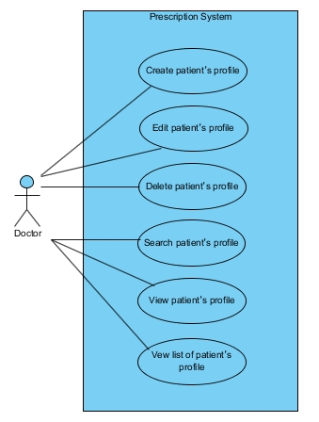

*Figure1: Prescription system diagram*

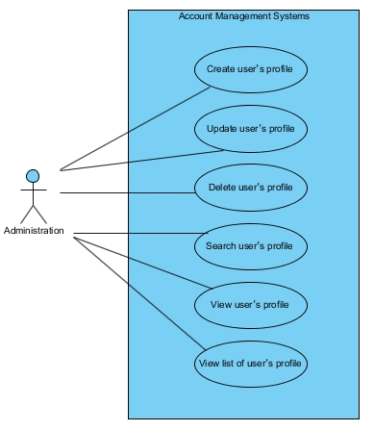

*Figure2: Account management system diagram*

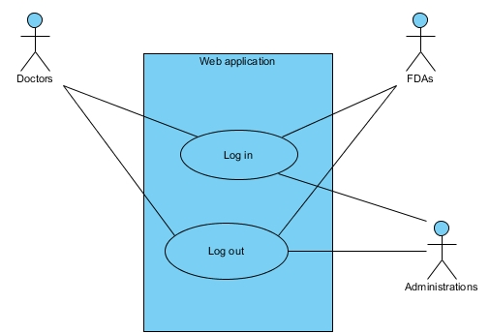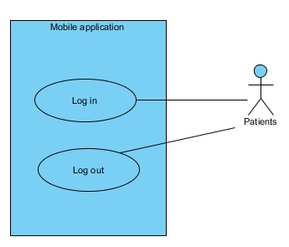

*Figure3: Authentication system diagram*

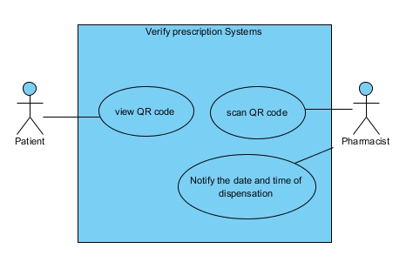

*Figure 4: Verify prescription system diagram*

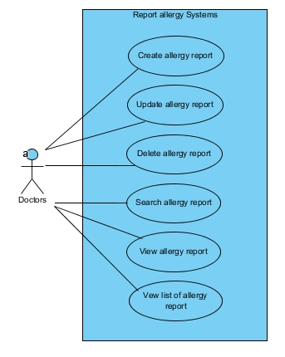

*Figure 5: Report allergy system diagram*

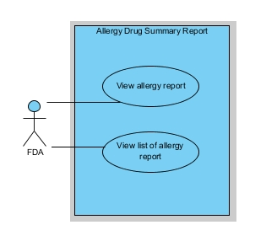

*Figure 6: Allergy drug summary report diagram*

## 4.2 Use Case Description

**4.2.1 Prescription system**

Feature#1: Prescription system

UC-1: Doctors can create patient’s profiles on the web application.

|  |  |  |  |
| --- | --- | --- | --- |
| **Use Case ID** | | **UC-1** | |
| Use Case Name: | | Doctor can create patient’s profiles on the web application. | |
| Actor: | | Doctors | |
| Description: | | Doctors create patient’s profiles to a system by inputting personal ID, name, surname, prescription, responsible, username, and code on create form. | |
| Trigger: | | Doctors select ‘patient profile’ on menu bars for view list of patient’s profile. | |
| Pre-conditions: | | Doctors need to log in by using doctor's side. | |
| Post-condition: | | System display patient’s profiles. | |
| **Use case input** | | | |
| **Input** | **Type** | **Constraints** | **Example** |
| personal ID | Int | Number | 1600100485726 |
| name | Varchar | Alphabetic | Natthakan |
| surname | Varchar | Alphabetic | Kaeokanpai |
| prescription | Longtext | Alphabetic or number or symbol | Parasetamol 5 mg. |
| responsible | Varchar | Alphabetic or symbol | Dr. mao |
| username | Varchar | Alphabetic or number | Up2man |
| code | Varchar | Alphabetic or number | 7885 |
| Normal Flows: | | 1. Doctors select ‘create button’ on operation menu bars. 2. System shall provide patient’s profiles form to doctor. 3. Doctors input personal ID, name, surname, prescription, responsible, username, and code of patient. 4. Doctors select ‘create button’. 5. System shall verify patient’s profiles form. 6. System shall create patient’s profiles to database. 7. System shall display information of patient’s profiles. | |
| Alternative Flows: | | 3(A).   1. If doctors do not input all data on patient’s profile form. (personal ID, name, surname, prescription, responsible, username, and code of patient’s profile) 2. System shall display message “Data cannot be blank”. 3. Resume on the 2nd step of normal flows.   3(B).   1. If doctors input wrong data of patient’s profile form   (Example: name = 123456).   1. System shall display message “Value is invalid”. 2. Resume on the 2nd step of normal flows. | |
| Exceptions: | | N/A | |

**Activity Diagram:(AD-1):**

*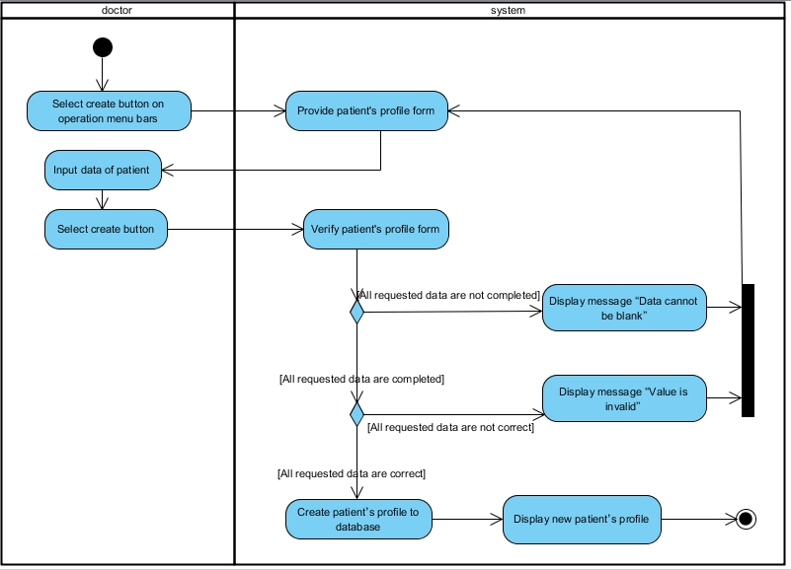Figure1: Activity Diagram AD-1*

UC-2: Doctors can update patient’s profiles on the web application.

|  |  |  |  |  |
| --- | --- | --- | --- | --- |
| **Use Case ID** | | | **UC-2** | |
| Use Case Name: | | | Doctors can update patient’s profiles on the web application. | |
| Actor: | | | Doctors | |
| Description: | | | Doctors select patient’s profiles for update by changing the default profile to new profile (personal ID, name, surname, prescription, responsible man, username, and code). | |
| Trigger: | | | Doctors select ‘patient profile’ on menu bars for view list of patient’s profile. | |
| Pre-conditions: | | | Doctors have to create a patient’s profile before updating. | |
| Post-condition: | | | Doctors can view new patient’s profiles on the patient’s profiles list. | |
| **Use case input** | | | | |
| **Input** | **Type** | **Constraints** | | **Example** |
| personal ID | Int | Number | | 1600100485726 |
| name | Varchar | Alphabetic | | Natthakan |
| surname | Varchar | Alphabetic | | Kaeokanpai |
| prescription | Longtext | Alphabetic or number or symbol | | Parasetamol 5 mg. |
| responsible | Varchar | Alphabetic or symbol | | Dr. mao |
| username | Varchar | Alphabetic or number | | Up2man |
| code | Varchar | Alphabetic or number | | 7885 |
| Normal Flows: | | | 1. Doctors select ‘manage’ button on operation menu bars. 2. System provides manage profile UI. 3. Doctors select ‘update button’ behind the patient’s profile. 4. System displays patient’s profile form that has default information of patient’s profile to doctor. 5. Doctor input data of patient (personal ID, name, surname, prescription, responsible, username, and code). 6. Doctors select ‘save’ button. 7. System verifies patient’s profile. 8. System updates the patient’s profile to database. 9. System displays information of patient’s profile. | |
| Alternative Flows: | | | 1(A).   1. Doctors select patient’s profile by click link personal ID on patient’s profile. 2. System provides information of patient’s profile. 3. Doctors select ‘update button’ on operation menu bars. 4. Resume on 2nd step of normal flows.   3(A).   1. If doctors do not input all data on patient’s profiles form. (personal ID, name, surname, prescription, responsible, username, and code of patient’s profile) 2. System displays message “Data cannot be blank”. 3. Resume on 2nd step of normal flows.   3(B).   1. If doctors input wrong data of patient’s profiles   (Example: name = 123456) on patient’s profiles form.   1. System displays message “Value is invalid”. 2. Resume on 2nd step of normal flows. | |

**Activity Diagram:(AD-2):**

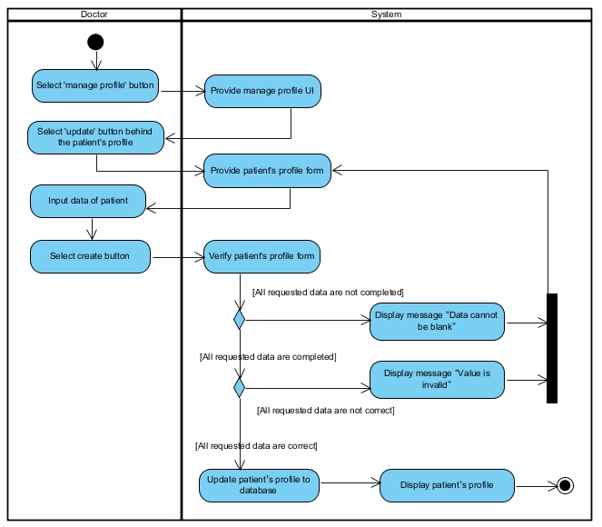

*Figure2: Activity Diagram AD-2*

UC-3: Doctors can delete patient’s profile on the web application.

|  |  |
| --- | --- |
| **Use Case ID** | **UC-3** |
| Use Case Name: | Doctors can delete patient’s profiles on the web application. |
| Actor: | Doctors |
| Description: | Doctors delete patient’s profiles from database. |
| Trigger: | Doctors select ‘patient profile’ on menu bars for view list of patient’s profile. |
| Pre-conditions: | Doctors need to log in by using doctor's side. |
| Post-condition: | System shall delete patient’s profiles from database. |
| Normal Flows: | 1. Doctors select ‘manage button’ on operation menu bars. 2. System provides manage profile UI. 3. Doctor selects ‘delete button’ behind of patient’s profiles. 4. System displays alert message “Are you sure you want to delete this item?” 5. Doctors select ‘confirm button’ on alert message. 6. System deletes the patient’s profiles from database |
| Alternative Flows: | 1(A).   1. Doctors select patient’s profile by click link personal ID on patient’s profile. 2. System provides information of patient’s profile. 3. Doctors select ‘delete button’ on operation menu bars. 4. Resume on 2nd step of normal flows.   3(A).   1. Doctors select ‘Cancel button’ on alert message. 2. System shall be not able to delete the patient’s profiles from the database. 3. Resume on 2nd step of normal flows. |
| Exceptions: | N/A |

**Activity Diagram:(AD-3)**

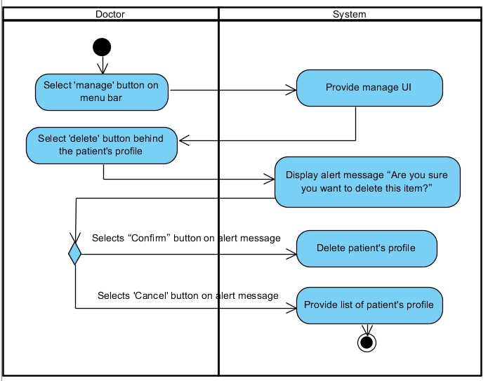

*Figure3: Activity Diagram AD-3*

UC-4: Doctors can search patient’s profile on the web application.

|  |  |
| --- | --- |
| **Use Case ID** | **UC-4** |
| Use Case Name: | Doctors can search patient’s profiles on the web application. |
| Actor: | Doctors |
| Description: | Doctors search patient’s profiles by input the name, surname, or personal ID of patient in search bars. |
| Trigger: | Doctors select ‘patient profile’ on menu bars for view list of patient’s profile. |
| Pre-conditions: | Doctors need to log in by using doctor's side. |
| Post-condition: | System shall display patient’s profiles that match with searching from database. |
| Normal Flows: | 1. Doctors select ‘manage’ button on operation menu bars. 2. System provides manage UI. 3. Doctors input name, surname, or personal ID of patient into the search bar. 4. Doctors press enter on keyboard. 5. System shall validate input data from doctors (name, surname, or personal ID). 6. System shall retrieve patient’s profiles from database. 7. System displays patient’s profiles on a list of the patient’s profiles. |
| Alternative Flows: | 7(A).   1. System shall display message “No results found” if there are no data in database. |

**Activity Diagram:(AD-4):**

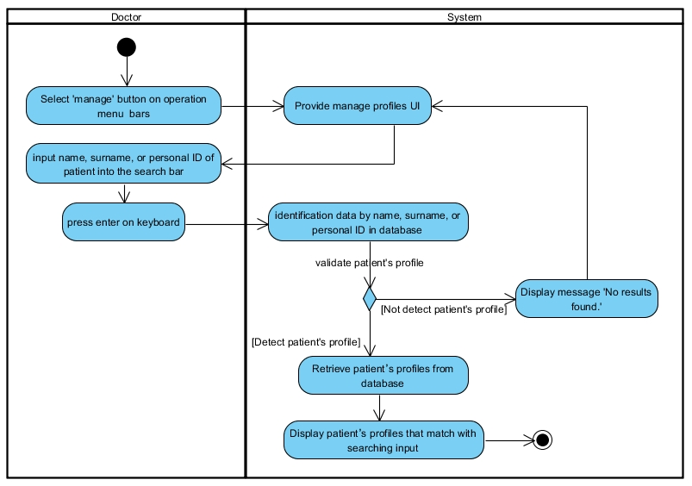

*Figure4: Activity Diagram AD-4*

UC-5: Doctors can view patient’s profile on the web application.

|  |  |
| --- | --- |
| **Use Case ID** | **UC-5** |
| Use Case Name: | Doctors can view patient’s profile on the web application. |
| Actor: | Doctors |
| Description: | Doctors view user’s profile on list of user’s profiles. |
| Trigger: | Doctors select ‘patient’s profile button’ on menu bars for view list of user’s profiles. |
| Pre-conditions: | Doctors need to log in by using administration's side. |
| Post-condition: | Doctors view information of user’s profiles. |
| Normal Flows: | 1. Doctors select patient’s profile on operation menu bars. 2. System provides patient’s profile UI. 3. Doctors select ‘patient’s profile’ by select link of personal ID on patient’s profile. 4. System retrieves patient’s profiles. 5. System displays information of patient’s profiles. |
| Alternative Flows: | N/A |

**Activity Diagram:(AD-5):**

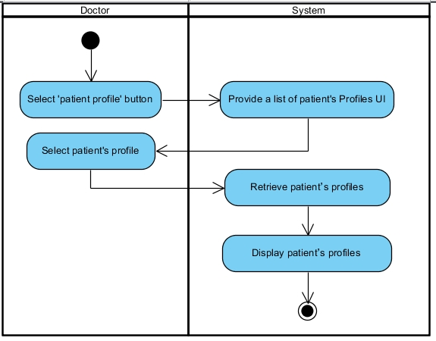

*Figure5: Activity Diagram AD-*5

UC-6: Doctors can view a list of patient’s profiles on the web application.

|  |  |
| --- | --- |
| **Use Case ID** | **UC-6** |
| Use Case Name: | Doctors can view a list of patient’s profiles on the web application. |
| Actor: | Doctors |
| Description: | Doctors view list of all patient’s profiles. |
| Trigger: | Doctors access to the web application. |
| Pre-conditions: | Doctors need to log in by using doctor's side. |
| Post-condition: | Doctors view a list of patient’s profiles. |
| Normal Flows: | 1. Doctors select ‘patient profile’ on menu bars. 2. System provides patient’s profiles UI. |
| Alternative Flows: | 1(A).   1. Doctors select ‘manage button’ on operation menu bars. 2. System provides manage profile UI, which includes list of patient’s profiles. |
| Exceptions: | 1. System shall not display patient’s profiles if there are no patient’s profiles in the list of patient’s profiles. |
| Includes: | N/A |
| Notes and Issues: | N/A |

**Activity Diagram:(AD-6):**

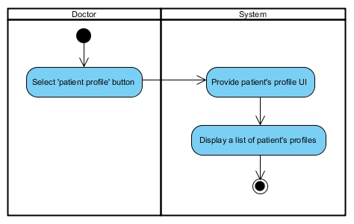

*Figure6: Activity Diagram AD-*6

**4.2.2 Account management system**

**Feature#2: Account management system**

UC-7: Administrations can create user’s profiles on the web application.

|  |  |  |  |
| --- | --- | --- | --- |
| Use Case ID | | UC-7 | |
| Use Case Name: | | Administrations can create user’s profiles on the web application. | |
| Actor: | | Administrations | |
| Description: | | Administrations create user’s profiles to the system by selecting position, inputting name, surname, username, and password on create form. | |
| Trigger: | | Administrations select ‘account button’ on menu bars for view list of user’s profiles. | |
| Pre-conditions: | | Administrations need to log in by using administration’s side. | |
| Post-condition: | | System shall display user’s profiles. | |
| **Use case input** | | | |
| **Input** | **Type** | **Constraints** | **Example** |
| position | Varchar | Alphabetic | Doctor |
| name | Varchar | Alphabetic | Natthakan |
| surname | Varchar | Alphabetic | Kaeokanpai |
| username | Varchar | Alphabetic or number | Up2man |
| password | Varchar | Alphabetic or number | 7885 |
| Normal Flows: | | 1. Administrations select ‘create button’ on operation menu bars. 2. System displays create form to administration. 3. Administrations input position, name, surname, username, and password of user. 4. Administrations select ‘create button’. 5. System verifies user’s profiles form. 6. System creates user’s profiles to database. 7. System displays information of user’s profiles. | |
| Alternative Flows: | | 3(A).   1. If administrations do not input all data of user’s profiles on user’s profiles form. 2. System displays message “Data cannot be blank”. 3. Resume on 2nd step of normal flows.   3(B).   1. If Administrations input wrong data of user’s profiles form. 2. (Example: name = 123456) on user’s profiles form. 3. System displays message “Value is invalid”. 4. Resume on 2nd step of normal flows. | |
| Exceptions: | | N/A | |

**Activity Diagram:(AD-7):**

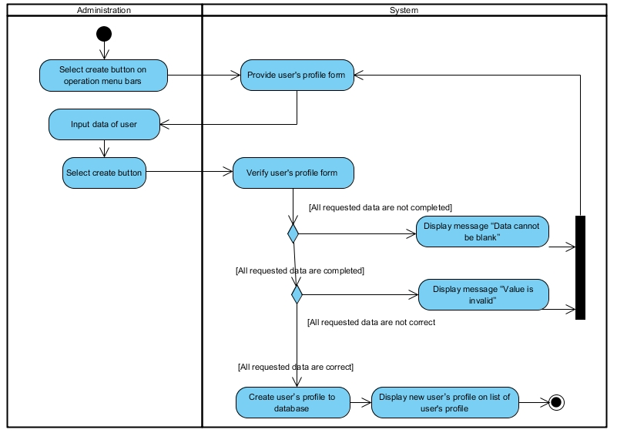

*Figure7: Activity Diagram AD-*7

UC-8: Administrations can update user’s profiles on the web application.

|  |  |  |  |
| --- | --- | --- | --- |
| **Use Case ID** | | UC-8 | |
| Use Case Name: | | Administrations can update user’s profiles on the web application. | |
| Actor: | | Administrations | |
| Description: | | Administrations update patient’s profiles by changing the default data to new profiles (personal ID, name, surname, prescription, responsible man, username, and code). | |
| Trigger: | | Administrations select ‘account button’ on menu bars for view list of user’s profiles. | |
| Pre-conditions: | | Administrations have to create a user’s profiles before updating. | |
| Post-condition: | | Administrations can view new user’s profiles on the list of user’s profiles. | |
| **Use case input** | | | |
| **Input** | **Type** | **Constraints** | **Example** |
| position | Varchar | Alphabetic | Doctor |
| name | Varchar | Alphabetic | Natthakan |
| surname | Varchar | Alphabetic | Kaeokanpai |
| username | Varchar | Alphabetic or number | Up2man |
| password | Varchar | Alphabetic or number | 7885 |
| Normal Flows: | | 1. Administrations select ‘manage button’ on operation menu bars. 2. System provides manage profile UI. 3. Administrations select ‘update button’ behind the user’s profile. 4. System displays user‘s profile form that has default information of user‘s profile to doctor. 5. Administrations input data of patient position, name, surname, username, and password of user. 6. Administrations select ‘save button’. 7. System verifies user‘s profile. 8. System updates the user‘s profile to database. 9. System displays information of user‘s profile. | |
| Alternative Flows: | | 5(A).   1. If administrations do not input all data of user’s profiles on user’s profiles form. 2. System displays message “Data cannot be blank”. 3. Resume on 4th step of normal flows.   5(B).   1. If Administrations input wrong data of user (Example: name = 123456) on user’s profiles form. 2. System displays message “Value is invalid”. 3. Resume on 4th step of normal flows. | |
| Exceptions: | | N/A | |

**Activity Diagram:(AD-8):**

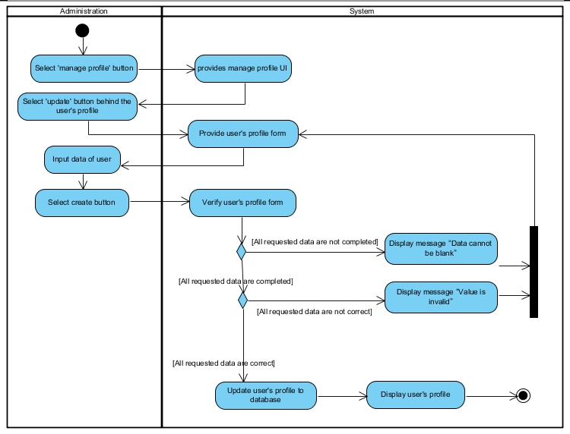

*Figure8: Activity Diagram AD-*8

UC-9: Administrations can delete user’s profiles on the web application.

|  |  |
| --- | --- |
| **Use Case ID** | UC-9 |
| Use Case Name: | Administrations can delete user’s profiles on the web application. |
| Actor: | Administrations |
| Description: | Administrations delete user’s profiles from user’s profiles list. |
| Trigger: | Administrations select ‘account button’ on menu bars for view list of user’s profiles. |
| Pre-conditions: | Administrations need to log in by using administration’s side. |
| Post-condition: | System shall delete user’s profiles from database. |
| Normal Flows: | 1. Administrations select ‘manage button’ on operation menu bars. 2. System provides manage profile UI. 3. Administrations select ‘delete button’. 4. System displays alert message “Are you sure you want to delete this item?” 5. Administrations select ‘confirm button’ on alert message. 6. System deletes the user’s profiles from database |
| Alternative Flows: | 3(A).   1. Administrations select “Cancel” button on alert message. 2. System is unable to delete the user’s profiles from the database. |
| Exceptions: | N/A |

**Activity Diagram :(AD-9)**

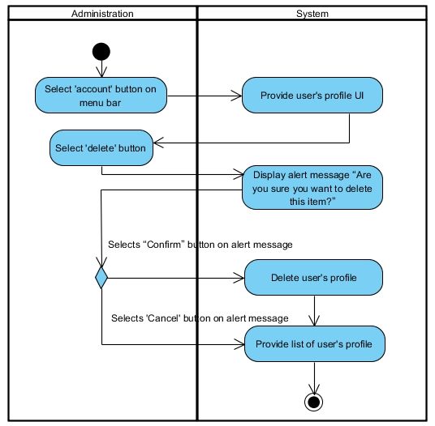

*Figure9: Activity Diagram AD-9*

UC-10: Administrations can search user’s profiles on the web application.

|  |  |
| --- | --- |
| **Use Case ID** | UC-10 |
| Use Case Name: | Administrations can search user’s profiles on the web application. |
| Actor: | Administrations |
| Description: | Administrations search user’s profiles by input the name, surname, or personal ID of user in search bars. |
| Trigger: | Administrations select ‘account button’ on menu bars for view list of user’s profiles. |
| Pre-conditions: | Administrations need to log in by using administration's side. |
| Post-condition: | System shall display user’s profiles that match with searching from database. |
| Normal Flows: | 1. Administrations select ‘manage button’ on operation menu bars. 2. System provides manage UI. 3. Administrations input name, surname, or position of user 4. Administrations press enter on keyboard. 5. System validates input data from administrations (name, surname, or position of user). 6. System retrieves user’s profiles from database. 7. System displays patient’s profiles on a list of the user’s profiles. |
| Alternative Flows: | 7(A).   1. System displays message “No results found” if there are no data in database. |
| Exceptions: | N/A |

**Activity Diagram:(AD-10):**

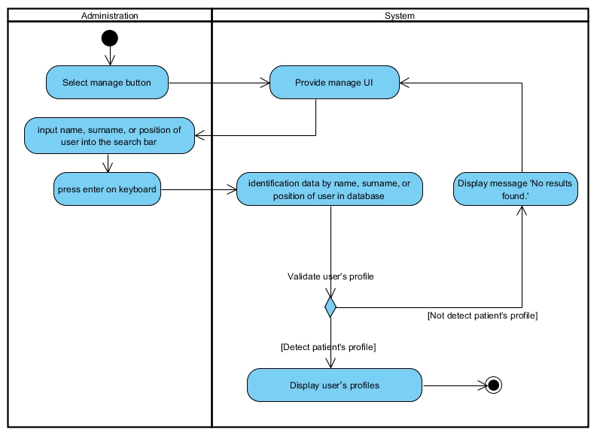

*Figure10: Activity Diagram AD-10*

UC-11: Administrations can view user’s profile on the web application.

|  |  |
| --- | --- |
| **Use Case ID** | UC-11 |
| Use Case Name: | Administrations can view user’s profiles on the web application. |
| Actor: | Administrations |
| Description: | Administrations view user’s profile on list of user’s profiles. |
| Trigger: | Administrations select ‘account button’ on menu bars for view list of user’s profiles. |
| Pre-conditions: | Administrations need to log in by using administration's side. |
| Post-condition: | Administrations views information of user’s profiles. |
| Normal Flows: | 1. Administrations select ‘manage button’ on operation menu bars. 2. System provides manage UI. 3. Administrations select ‘view button’. 4. System displays information of user’s profiles. |
| Alternative Flows: | N/A |
| Exceptions: | 1. System shall not display user’s profiles if there are no user’s profiles in the list of user’s profiles. |

**Activity Diagram:(AD-11):**

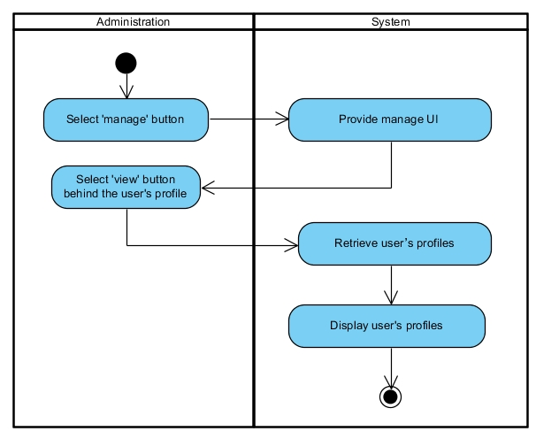

*Figure11: Activity Diagram AD-11*

UC-12: Administrations can view a list of user’s profiles on the web application.

|  |  |
| --- | --- |
| Use Case ID | UC-12 |
| Use Case Name: | Administrations can view list of user’s profiles. |
| Actor: | Administrations |
| Description: | Administrations view a list of user’s profiles. |
| Trigger: | Administrations select ‘account button’ on menu bars for view list of user’s profiles. |
| Pre-conditions: | Administrations need to log in by using administration's side. |
| Post-condition: | Administrations view a list of user’s profiles. |
| Normal Flows: | 1. Administrations select ‘manage button’ on operation menu bars. 2. System provides manage profile UI, which includes list of user’s profiles. |
| Alternative Flows: | N/A |
| Exceptions: | 1. System shall not display user’s profiles if there is no user’s profile in the list of user’s profiles. |

**Activity Diagram:(AD-12):**

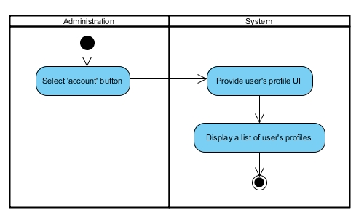

*Figure12: Activity Diagram AD-12*

**4.2.1 Authentication system**

**Feature#3: Authentication system**

UC-13: Doctors, Administrations, and FDAs can login to the web application.

|  |  |
| --- | --- |
| **Use Case ID** | **UC-13** |
| Use Case Name: | Doctors, Administrations, or FDAs can login to the web application. |
| Actor: | Doctors, Administrations, or FDAs |
| Description: | Doctors, Administrations, or FDAs access to the web application. |
| Trigger: | Doctors, Administrations, or FDAs access to the web application |
| Pre-conditions: | Doctors, Administrations, or FDAs already have ID and password. |
| Post-condition: | System provides main page with menu bars. |
| Normal Flows: | 1. Doctors, Administrations, or FDAs select login button on menu bars. 2. System shall display the login form. 3. Doctors, Administrations, or FDAs input username and password to the login form. 4. Doctors, Administrations, or FDAs select login button on login form. 5. System shall validate username and password from database. 6. System shall redirect doctors, administrations, or FDAs to main page, which includes menu bars and operation menu bars. |
| Alternative Flows: | 4(A).   1. System shall display message “Incorrect username or password” if users input username or password incorrectly. 2. System shall processing follow 2nd step in normal flows.   4(B).   1. System shall display message “Cannot be blank “ if user do not input username or password on login form. 2. System shall processing follow 2nd step in normal flows. |
| Exceptions: | N/A |

**Activity Diagram:(AD-13):**

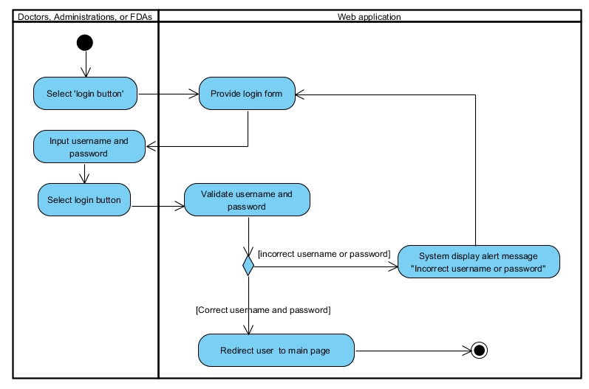

*Figure13: Activity Diagram AD-13*

UC-14: Doctors, Administrations, and FDAs can logout from the web application.

|  |  |
| --- | --- |
| **Use Case ID** | **UC-14** |
| Use Case Name: | Doctors, Administrations, and FDAs can logout from application. |
| Actor: | Doctors, Administrations, and FDAs |
| Description: | Doctors, Administrations, and FDAs log out from system by click logout button on menu bars. |
| Trigger: | Doctors, Administrations, and FDAs select logout button on menu bar. |
| Pre-conditions: | Doctors, Administrations, and FDAs have to login to system before logout. |
| Post-condition: | System shall provide login page to user. |
| Normal Flows: | 1. Doctors, Administrations, and FDAs select logout button on menu bars. 2. System shall redirect doctors, administrations, and FDAs to login page. |
| Alternative Flows: | N/A |
| Exceptions: | N/A |

**Activity Diagram:(AD-14):**

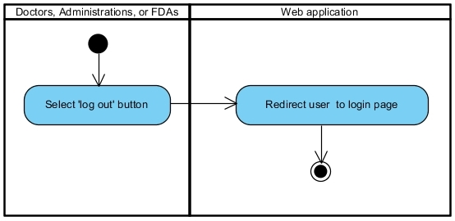

*Figure14: Activity Diagram AD-14*

UC-15: Patients can login to the mobile application.

|  |  |
| --- | --- |
| **Use Case ID** | **UC-15** |
| Use Case Name: | Patients can login to the mobile application. |
| Actor: | Patients |
| Description: | Patients access to the mobile application. |
| Trigger: | Patients select login button on menu bars. |
| Pre-conditions: | Patients already have ID and password. |
| Post-condition: | System provides main page with menu bars. |
| Normal Flows: | 1. Patients access to the mobile application. 2. System displays the login form. 3. Pharmacists and patients input username and password to the login form. 4. Patients select login button on login form. 5. System validates username and password from database. 6. System redirects patients to the main page, which includes ‘show QR code’ button and ‘exit’ button |
| Alternative Flows: | 4(A).   1. System display message “Incorrect username or password” if users input username or password incorrectly. 2. System processing follow 6th step in normal flows.   4(B).   1. System displays message “Cannot be blank “ if user do not input username or password on login form. 2. System processing follow 6th step in normal flows. |
| Exceptions: | N/A |

**Activity Diagram:(AD-15):**

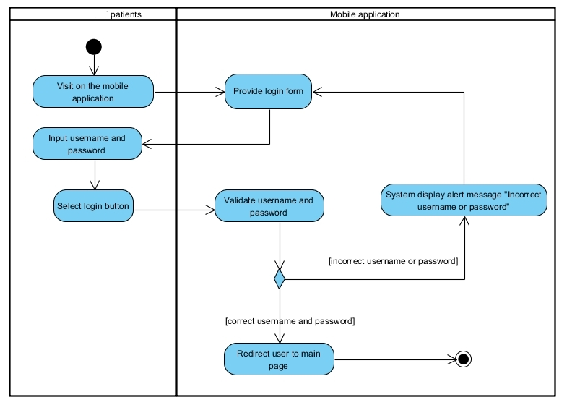

*Figure15: Activity Diagram AD-15*

UC-16: Patients can logout from the mobile application.

|  |  |
| --- | --- |
| **Use Case ID** | **UC-16** |
| Use Case Name: | Patients can logout from the mobile application. |
| Actor: | Patients |
| Description: | Patients log out from system by click logout button on menu bars. |
| Trigger: | Patients select logout button on menu bar. |
| Pre-conditions: | Patients have to login to system before logout. |
| Post-condition: | System shall provide login page to user. |
| Normal Flows: | 1. Patients select logout button on menu bars. 2. System shall redirect pharmacists and patients to login page. |
| Alternative Flows: | N/A |
| Exceptions: | N/A |

**Activity Diagram:(AD-16):**

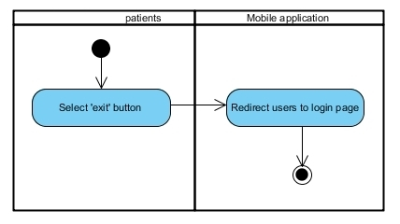

*Figure16: Activity Diagram AD-16*

**4.2.1 Verify prescription system**

**Feature#4: Verify prescription system**

UC-17: Patients can view the QR code on the mobile application.

|  |  |
| --- | --- |
| **Use Case ID** | **UC-17** |
| Use Case Name: | Patients can view QR code on the mobile application. |
| Actor: | Patients |
| Description: | Patient view QR code on a mobile application. |
| Trigger: | Patients select ‘Show QR code’ button. |
| Pre-conditions: | Doctors have to created patient’s profile. |
| Post-condition: | System shall display QR code to patient on a mobile application. |
| Normal Flows: | 1. Patients access to the mobile application. 2. System retrieves QR code of profile’s profiles from database. 3. System displays the QR code on screen. |
| Alternative Flows: | N/A |
| Exceptions: | N/A |

**Activity Diagram:(AD-17):**

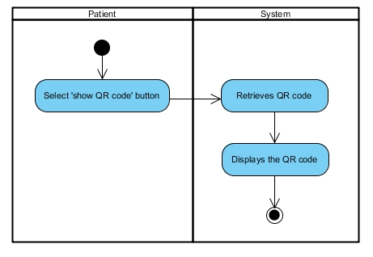

*Figure17: Activity Diagram AD-17*

UC-18 Pharmacists can scan QR code on the mobile application.

|  |  |
| --- | --- |
| **Use Case ID** | **UC-18** |
| Use Case Name: | Pharmacists can scan QR code on the mobile application. |
| Actor: | Pharmacists |
| Description: | Pharmacists scan QR code prescription by select scan on login page on a mobile application. |
| Trigger: | Pharmacists select ‘scan’ button on login page. |
| Pre-conditions: | Pharmacists need to access to the mobile application. |
| Post-condition: | System shall display information of patient to pharmacist on a mobile application. |
| Normal Flows: | 1. Pharmacists select scan button on login page. 2. Systems provide scan QR code function on the mobile application. 3. Pharmacists scan QR code. 4. System display information of patient’s profiles to Pharmacists on the mobile application. |
| Alternative Flows: | N/A |
| Exceptions: | N/A |

**Activity Diagram:(AD-18):**

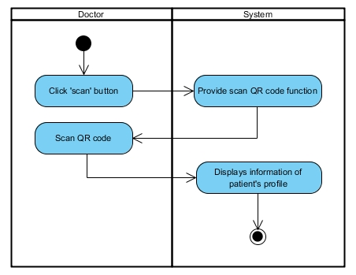

*Figure18: Activity Diagram AD-18*

UC-19: Pharmacists can notify the time of dispensation to patient’s profile on the mobile application.

|  |  |
| --- | --- |
| **Use Case ID** | **UC-19** |
| Use Case Name: | Pharmacists can notify the time of dispensation to patient’s profile on the mobile application. |
| Actor: | Pharmacists |
| Description: | System shall record the present time and date to database by pharmacists click confirm button on patient’s profile for notify the time of dispensation to patient’s profile on the mobile application. |
| Trigger: | Pharmacists have to scan QR code. |
| Pre-conditions: | Pharmacists access to the mobile application. |
| Post-condition: | System shall display information of patient to pharmacist on a mobile application. |
| Normal Flows: | 1. Pharmacists select ‘Confirm’ button on patient’s profile page. 2. Systems record the date and time to the database. |
| Alternative Flows: | N/A |
| Exceptions: | N/A |

**Activity Diagram:(AD-19):**

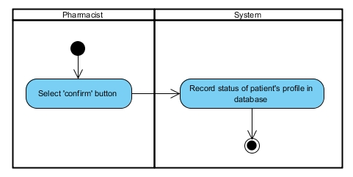

*Figure19: Activity Diagram AD-19*

**4.2.1 Report allergy system**

**Feature#5: Report allergy system**

UC-20: Doctors can create allergy reports on the web application.

|  |  |  |  |  |
| --- | --- | --- | --- | --- |
| **Use Case ID** | | **UC-20** | | |
| Use Case Name: | | Doctors can create allergy reports on the web application. | | |
| Actor: | | Doctors | | |
| Description: | | Doctors create allergy reports to the system by input name, surname, personal ID, and allergy drug on the allergy report. | | |
| Trigger: | | Doctors select ‘allergy report’ button on menu bars. | | |
| Pre-conditions: | | Doctors need to log in by using doctor's side. | | |
| Post-condition: | | System displays allergy report. | | |
| **Use case input** | | | | |
| **Input** | **Type** | | **Constraints** | **Example** |
| personal ID | Int | | Number | 1600100485726 |
| name | Varchar | | Alphabetic | Natthakan |
| surname | Varchar | | Alphabetic | Kaeokanpai |
| allergy report | Varchar | | Alphabetic or number or symbol | Parasetamol 5 mg. |
| Normal Flows: | | 1. Doctors select ‘create button’ on operation menu bars. 2. System displays allergy report form to doctor. 3. Doctors input data of allergy report by input name, surname, personal ID, and allergy drug. 4. Doctors select ‘create button’. 5. System verifies allergy report form. 6. System creates allergy reports to database. 7. System displays information of allergy reports. | | |
| Alternative Flows: | | 1(A).   1. Doctors select allergy reports by click link of allergy ID on allergy reports. 2. System provides information of allergy report.. 3. Doctors select ‘update button’ on operation menu bars. 4. Resume on 2nd step of normal flows.   3(A).   1. If doctor do not input name, surname, personal ID, or allergy drug of allergy report on allergy report form. 2. System shall display message “Data cannot be blank”. 3. Resume on 2nd step of normal flows.   3(B).   1. If doctor input wrong data (name, surname, personal ID, or allergy drug).   (Example: name = 123456) on allergy report form.   1. System displays message “Value is invalid”. 2. Resume on 2nd step of normal flows. | | |
| Exceptions: | | N/A | | |

**Activity Diagram:(AD-20):**

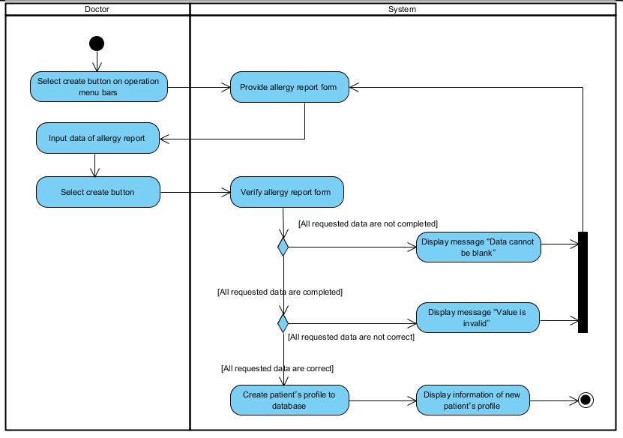

*Figure20: Activity Diagram AD-20*

UC-21: Doctors can update allergy report on the web application.

|  |  |  |  |  |
| --- | --- | --- | --- | --- |
| **Use Case ID** | | **UC-21** | | |
| Use Case Name: | | Doctors can update allergy report on the web application. | | |
| Actor: | | Doctors | | |
| Description: | | Doctors update allergy report by changing the default data to new reports (name, surname, personal ID, and allergy drug of the allergy report). | | |
| Trigger: | | Doctors select ‘allergy report’ button on menu bars. | | |
| Pre-conditions: | | Doctors have to create allergy report before updating. | | |
| Post-condition: | | Doctors can view a new allergy report on the list of allergy report list. | | |
| **Use case input** | | | | |
| **Input** | **Type** | | **Constraints** | **Example** |
| personal ID | Int | | Number | 1600100485726 |
| name | Varchar | | Alphabetic | Natthakan |
| surname | Varchar | | Alphabetic | Kaeokanpai |
| allergy report | Varchar | | Alphabetic or number or symbol | Parasetamol 5 mg. |
| Normal Flows: | | 1. Doctors select ‘manage’ button on operation menu bars. 2. System provides manage UI. 3. Doctors select ‘update button’ behind the allergy report. 4. System displays update form that has default information of allergy report to doctor. 5. Doctor input name, surname, personal ID, and allergy drug of allergy report. 6. Doctor select create button. 7. System updates the allergy report to database. 8. System displays information of allergy report. | | |
| Alternative Flows: | | 1(A).   1. Doctors select allergy report by click link of allergy ID on allergy report. 2. System provides information of allergy report. 3. Doctors select ‘update button’ on operation menu bars. 4. Resume on 2nd step of normal flows.   4(A).   1. If doctor do not input name, surname, personal ID, or allergy drug of the allergy report on create form. 2. System shall display message “Data cannot be blank”. 3. Doctor input all data to create form. 4. Resume on 5th step of normal flows.   4(B).   1. If doctor input wrong name, surname, personal ID of patient (Example: name = 123456) on create form. 2. System shall display message “Value is invalid”. 3. Doctors input correct data. 4. Resume on 5th step of normal flows. | | |
| Exceptions: | | N/A | | |

**Activity Diagram:(AD-21):**

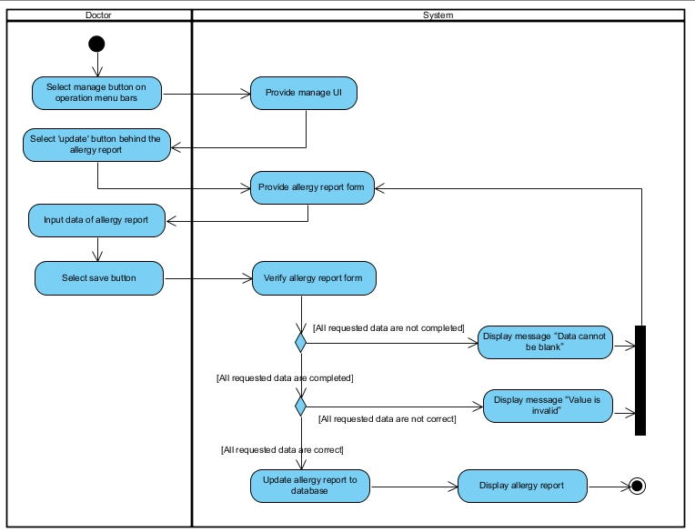

*Figure21: Activity Diagram AD-21*

UC-22: Doctor can delete allergy report on the web application.

|  |  |
| --- | --- |
| **Use Case ID** | **UC-22** |
| Use Case Name: | Doctors can delete allergy reports on the web application. |
| Actor: | Doctors |
| Description: | Doctors delete allergy reports from a list of allergy reports. |
| Trigger: | Doctors select ‘allergy report’ button on menu bars. |
| Pre-conditions: | Doctors need to log in by using doctor's side. |
| Post-condition: | System shall delete allergy report from database. |
| Normal Flows: | 1. Doctors select ‘manage button’ on operation menu bars. 2. System provides manage profile UI. 3. Doctor selects ‘delete button’ behind of allergy report. 4. System displays alert message “Are you sure you want to delete this item?” 5. Doctors select ‘confirm button’ on alert message.   System deletes the allergy report from database |
| Alternative Flows: | 1(A).   1. Doctors select allergy report by click link allergy report ID on allergy report. 2. System provides information of allergy report. 3. Doctors select ‘delete button’ on operation menu bars. 4. Resume on 4th step of normal flows.   3(A).   1. Doctors select ‘Cancel button’ on alert message. 2. System shall be not able to delete the allergy report from the database. 3. Resume on 2nd step of normal flows. |

**Activity Diagram:(AD-22):**

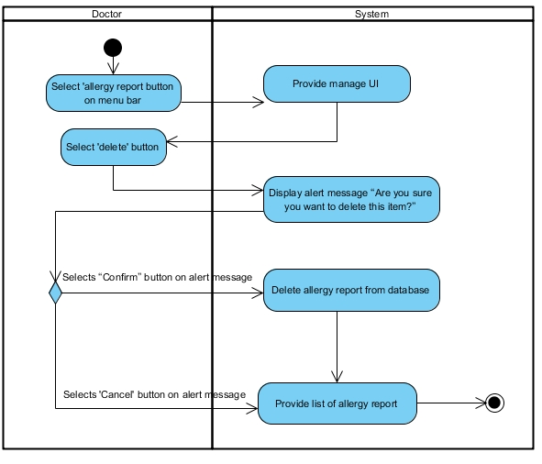

*Figure22: Activity Diagram AD-22*

UC-23: Doctors can search allergy reports on the web application.

|  |  |
| --- | --- |
| **Use Case ID** | **UC-23** |
| Use Case Name: | Doctors can search allergy reports on the web application. |
| Actor: | Doctors |
| Description: | Doctors search allergy reports by input the name, surname, or personal ID of patient in search bars. |
| Trigger: | Doctors select ‘allergy report’ button on menu bars. |
| Pre-conditions: | Doctors need to log in by using doctor's side. |
| Post-condition: | System shall display allergy report that match with searching from database. |
| Normal Flows: | 1. Doctors select ‘manage button’ on operation menu bars. 2. System provides manage UI. 3. Doctors input name, surname, or allergy drug of allergy report into the search bar. 4. Doctors press enter on keyboard. 5. System shall validate input data from doctors (name, surname, or allergy drug). 6. System shall retrieve allergy report from database. 7. System displays allergy report on a list of the allergy report. |
| Alternative Flows: | 4(A).   1. System shall display message “No results found” if there is no data in database. |

**Activity Diagram:(AD-23):**

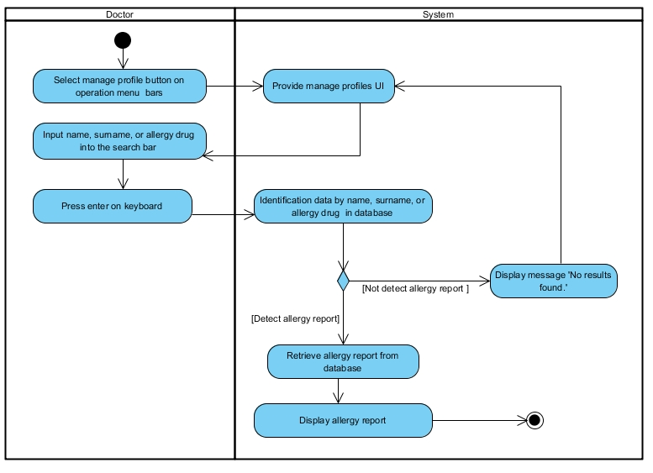

*Figure23: Activity Diagram AD-23*

UC-24: Doctors can view allergy reports on the web application.

|  |  |
| --- | --- |
| **Use Case ID** | **UC-24** |
| Use Case Name: | Doctors can view allergy reports on the web application |
| Actor: | Doctors |
| Description: | Doctors view allergy reports on a list of allergy reports. |
| Trigger: | Doctors select ‘allergy report’ button on menu bars. |
| Pre-conditions: | Doctors need to log in by using doctor's side. |
| Post-condition: | Doctors view information of allergy reports. |
| Normal Flows: | 1. Doctor select allergy reports by click link allergy ID on allergy reports. 2. System retrieves allergy reports. 3. System displays information of allergy reports |
| Alternative Flows: | 1(A).   1. Doctors select ‘manage button’ on operation menu bars. 2. System provides manage profile UI. 3. Doctor selects ‘view button’ behind of allergy reports. 4. Resume on 2th step of normal flows. |
| Exceptions: | 1. System shall not display allergy report if there are no allergy reports in the allergy report list. |

**Activity Diagram:(AD-24):**

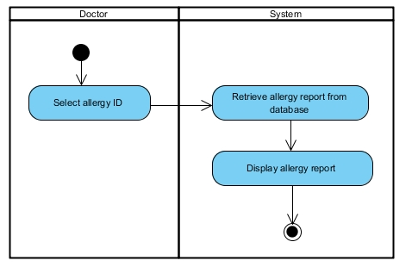

*Figure24: Activity Diagram AD-24*

UC-25: Doctors can view a list of allergy reports on the web application.

|  |  |
| --- | --- |
| **Use Case ID** | **UC-25** |
| Use Case Name: | Doctors can view a list of allergy reports on the web application. |
| Actor: | Doctors |
| Description: | Doctors view list of all allergy reports. |
| Pre-conditions: | Doctors need to log in by using doctor's side. |
| Post-condition: | Doctors view a list of all allergy reports. |
| Normal Flows: | 1. Doctors select ‘allergy report’ on menu bars. 2. System provides a list of allergy report UI, which includes list of allergy report. |
| Alternative Flows: | 1(A).   1. Doctors select ‘manage button’ on operation menu bars. 2. System provides manage profile UI, which includes list of allergy reports. |
| Exceptions: | 1. System shall not display list of allergy reports if there are no allergy reports. |
| Includes: | N/A |
| Notes and Issues: | N/A |

**Activity Diagram:(AD-25):**

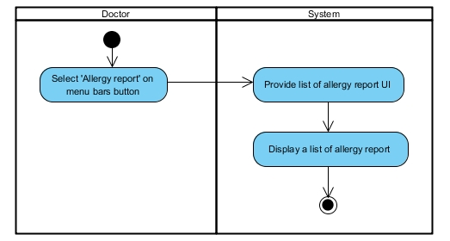

*Figure25: Activity Diagram AD-*25

**4.2.1 Allergy drug summary report**

**Feature#6: Allergy drug summary report**

UC-26: FDAs can view allergy reports on the web application.

|  |  |
| --- | --- |
| **Use Case ID** | **UC-26** |
| Use Case Name: | FDAs can view allergy report on the web application. |
| Actor: | FDAs |
| Description: | FDAs view allergy report on a list of allergy reports. |
| Trigger: | FDAs select ‘allergy report’ button on menu bars. |
| Pre-conditions: | FDAs need to log in by using FDA’s side. |
| Post-condition: | FDAs view information of allergy report. |
| Normal Flows: | 1. FDAs select allergy reports by click link allergy ID on allergy reports. 2. System retrieves allergy reports. 3. System displays information of allergy reports. |
| Alternative Flows: | 1(A).   1. FDAs select ‘manage’ button on operation menu bars. 2. System provides manage profile UI. 3. FDAs selects ‘view’ button behind of allergy reports. 4. Resume on 2th step of normal flows. |
| Exceptions: | 1. System shall not display allergy report if there are no allergy reports in the allergy report list. |

**Activity Diagram:(AD-26):**

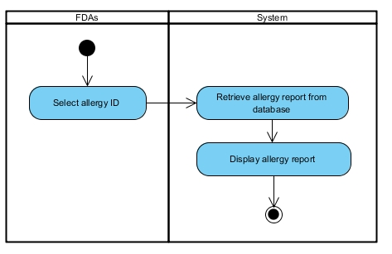

*Figure26: Activity Diagram AD-26*

UC-27: FDA can view a list of allergy report on the web application.

|  |  |
| --- | --- |
| **Use Case ID** | **UC-27** |
| Use Case Name: | FDAs can view a list of allergy reports on the web application. |
| Actor: | FDAs |
| Description: | FDAs view a list of all allergy reports. |
| Trigger: | FDAs access to the web application. |
| Pre-conditions: | FDAs need to log in by using FDA's side. |
| Post-condition: | FDAs view a list of all allergy reports. |
| Normal Flows: | 1. Doctors select ‘allergy report ‘button on menu bars. 2. System provides a list of allergy report UI, which includes list of allergy report. |
| Alternative Flows: | 1(A).   1. Doctors select ‘manage button’ on operation menu bars. 2. System provides manage UI, which includes list of allergy reports. |
| Exceptions: | 1. System shall not displays list of allergy report if there are no allergy reports. |

**Activity Diagram:(AD-27):**

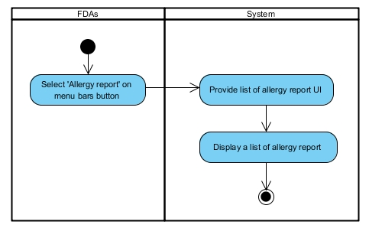

*Figure27: Activity Diagram AD-27*

# Chapter Five | References

[1] Definition of User Interface.   
<http://searchsoa.techtarget.com/definition/user-interface>

[2] Definition of Use Case Diagram.   
<http://en.wikipedia.org/wiki/Use_Case_Diagram>

[3] Definition of Activity Diagram.   
<http://en.wikipedia.org/wiki/Activity_diagram>